|  |  |  |  |  |
| --- | --- | --- | --- | --- |
| **$NSSFBENEFITS Frequencies** | | | | |
|  | | Responses | | Percent of Cases |
| N | Percent |
| Benefits of NSSFa | Age_benefits | 7 | 18.9% | 70.0% |
| Survival_benefit | 6 | 16.2% | 60.0% |
| Invalidity_benefit | 6 | 16.2% | 60.0% |
| Funeral_benefit | 5 | 13.5% | 50.0% |
| Emigration_benefit | 6 | 16.2% | 60.0% |
| Withdrawal_benefit | 7 | 18.9% | 70.0% |
| Total | | 37 | 100.0% | 370.0% |
| a. Dichotomy group tabulated at value 1. | | | | |

|  |  |  |  |  |
| --- | --- | --- | --- | --- |
| **$Awareness Frequencies** | | | | |
|  | | Responses | | Percent of Cases |
| N | Percent |
| Awareness about NSSFa | Gender | 5 | 9.8% | 50.0% |
| Radio_awareness | 6 | 11.8% | 60.0% |
| Tv_awareness | 6 | 11.8% | 60.0% |
| Newspaper_awareness | 6 | 11.8% | 60.0% |
| Friends_relatives_colleagues | 6 | 11.8% | 60.0% |
| Publicity_boards_awareness | 7 | 13.7% | 70.0% |
| Employer_awareness | 7 | 13.7% | 70.0% |
| Visiting_their_premises | 4 | 7.8% | 40.0% |
| other_sources | 4 | 7.8% | 40.0% |
| Total | | 51 | 100.0% | 510.0% |
| a. Dichotomy group tabulated at value 1. | | | | |

|  |  |  |  |  |  |  |
| --- | --- | --- | --- | --- | --- | --- |
| **Case Processing Summary** | | | | | | |
|  | Cases | | | | | |
| Valid | | Missing | | Total | |
| N | Percent | N | Percent | N | Percent |
| Gender * Age | 10 | 100.0% | 0 | 0.0% | 10 | 100.0% |
| Gender * Region | 10 | 100.0% | 0 | 0.0% | 10 | 100.0% |
| Occupation * Age | 10 | 100.0% | 0 | 0.0% | 10 | 100.0% |
| Occupation * Region | 10 | 100.0% | 0 | 0.0% | 10 | 100.0% |

|  |  |  |  |  |  |  |  |
| --- | --- | --- | --- | --- | --- | --- | --- |
| **Gender * Age Crosstabulation** | | | | | | | |
| Count | | | | | | | |
|  | | Age | | | | | Total |
| 18-24 | 23-34 | 35-44 | 45-54 | 55+ |
| Gender | Male | 0 | 2 | 2 | 0 | 1 | 5 |
| Female | 2 | 0 | 0 | 2 | 1 | 5 |
| Total | | 2 | 2 | 2 | 2 | 2 | 10 |

|  |  |  |  |  |  |  |  |
| --- | --- | --- | --- | --- | --- | --- | --- |
| **Gender * Region Crosstabulation** | | | | | | | |
| Count | | | | | | | |
|  | | Region | | | | | Total |
| Central | Coast/NorthEast | Nairobi | Nyanza/Western | Riftvalley |
| Gender | Male | 2 | 1 | 1 | 0 | 1 | 5 |
| Female | 0 | 1 | 1 | 2 | 1 | 5 |
| Total | | 2 | 2 | 2 | 2 | 2 | 10 |
|  | |  |  |  |  |  |  |

|  |  |  |  |  |  |  |  |
| --- | --- | --- | --- | --- | --- | --- | --- |
| **Occupation * Age Crosstabulation** | | | | | | | |
| Count | | | | | | | |
|  | | Age | | | | | Total |
| 18-24 | 23-34 | 35-44 | 45-54 | 55+ |
| Occupation | Employed | 2 | 0 | 1 | 1 | 0 | 4 |
| Self_employed | 0 | 2 | 0 | 0 | 2 | 4 |
| Claimant | 0 | 0 | 1 | 1 | 0 | 2 |
| Total | | 2 | 2 | 2 | 2 | 2 | 10 |

|  |  |  |  |  |  |  |  |
| --- | --- | --- | --- | --- | --- | --- | --- |
| **Occupation * Region Crosstabulation** | | | | | | | |
| Count | | | | | | | |
|  | | Region | | | | | Total |
| Central | Coast/NorthEast | Nairobi | Nyanza/Western | Riftvalley |
| Occupation | Employed | 0 | 0 | 2 | 2 | 0 | 4 |
| Self_employed | 1 | 1 | 0 | 0 | 2 | 4 |
| Claimant | 1 | 1 | 0 | 0 | 0 | 2 |
| Total | | 2 | 2 | 2 | 2 | 2 | 10 |

**Frequencies**

|  |  |  |
| --- | --- | --- |
| **Notes** | | |
| Output Created | | 21-OCT-2022 21:22:38 |
| Comments | |  |
| Input | Data | C:\Users\Owner\Desktop\Done Assignment.sav |
| Active Dataset | DataSet1 |
| Filter | <none> |
| Weight | <none> |
| Split File | <none> |
| N of Rows in Working Data File | 10 |
| Missing Value Handling | Definition of Missing | User-defined missing values are treated as missing. |
| Cases Used | Statistics are based on all cases with valid data. |
| Syntax | | FREQUENCIES VARIABLES=Gender Age Occupation Region  /BARCHART FREQ  /ORDER=ANALYSIS. |
| Resources | Processor Time | 00:00:01.33 |
| Elapsed Time | 00:00:03.73 |

|  |  |  |  |  |  |
| --- | --- | --- | --- | --- | --- |
| **Statistics** | | | | | |
|  | | Gender | Age | Occupation | Region |
| N | Valid | 10 | 10 | 10 | 10 |
| Missing | 0 | 0 | 0 | 0 |

**Frequency Table**

|  |  |  |  |  |  |
| --- | --- | --- | --- | --- | --- |
| **Gender** | | | | | |
|  | | Frequency | Percent | Valid Percent | Cumulative Percent |
| Valid | Male | 5 | 50.0 | 50.0 | 50.0 |
| Female | 5 | 50.0 | 50.0 | 100.0 |
| Total | 10 | 100.0 | 100.0 |  |

|  |  |  |  |  |  |
| --- | --- | --- | --- | --- | --- |
| **Age** | | | | | |
|  | | Frequency | Percent | Valid Percent | Cumulative Percent |
| Valid | 18-24 | 2 | 20.0 | 20.0 | 20.0 |
| 23-34 | 2 | 20.0 | 20.0 | 40.0 |
| 35-44 | 2 | 20.0 | 20.0 | 60.0 |
| 45-54 | 2 | 20.0 | 20.0 | 80.0 |
| 55+ | 2 | 20.0 | 20.0 | 100.0 |
| Total | 10 | 100.0 | 100.0 |  |

|  |  |  |  |  |  |
| --- | --- | --- | --- | --- | --- |
| **Occupation** | | | | | |
|  | | Frequency | Percent | Valid Percent | Cumulative Percent |
| Valid | Employed | 4 | 40.0 | 40.0 | 40.0 |
| Self_employed | 4 | 40.0 | 40.0 | 80.0 |
| Claimant | 2 | 20.0 | 20.0 | 100.0 |
| Total | 10 | 100.0 | 100.0 |  |

|  |  |  |  |  |  |
| --- | --- | --- | --- | --- | --- |
| **Region** | | | | | |
|  | | Frequency | Percent | Valid Percent | Cumulative Percent |
| Valid | Central | 2 | 20.0 | 20.0 | 20.0 |
| Coast/NorthEast | 2 | 20.0 | 20.0 | 40.0 |
| Nairobi | 2 | 20.0 | 20.0 | 60.0 |
| Nyanza/Western | 2 | 20.0 | 20.0 | 80.0 |
| Riftvalley | 2 | 20.0 | 20.0 | 100.0 |
| Total | 10 | 100.0 | 100.0 |  |

**Bar Chart**

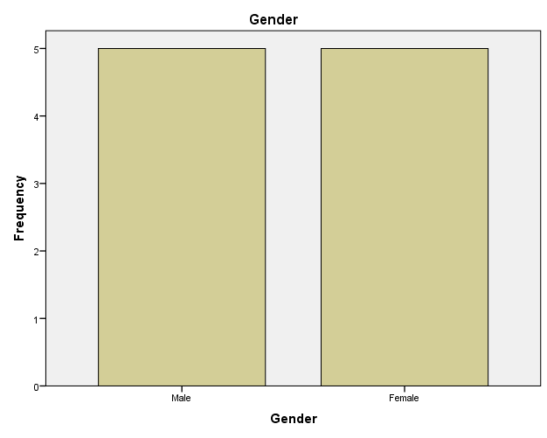

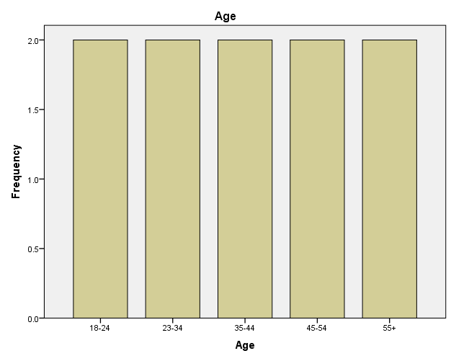

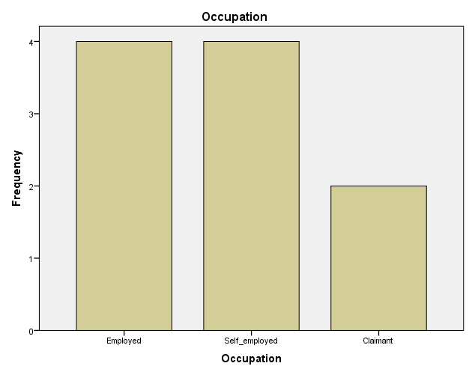

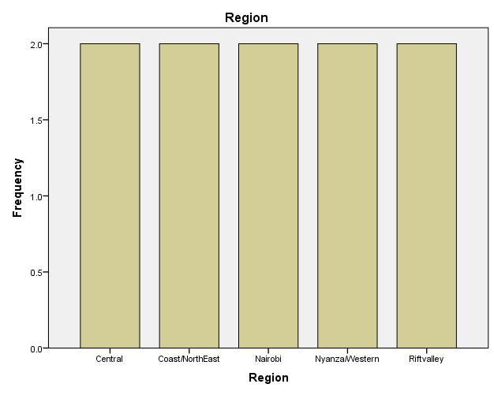

**Multiple Response Set**

|  |  |  |
| --- | --- | --- |
| **Notes** | | |
| Output Created | | 21-OCT-2022 21:35:01 |
| Comments | |  |
| Input | Data | C:\Users\Owner\Desktop\Done Assignment.sav |
| Active Dataset | DataSet1 |
| Filter | <none> |
| Weight | <none> |
| Split File | <none> |
| N of Rows in Working Data File | 10 |
| Syntax | | MRSETS  /MDGROUP NAME=$corevalues LABEL='Core values practised by NSSF' CATEGORYLABELS=VARLABELS VARIABLES=No_Corruptionact Betterways_of_delivering_services Act_responsibly Worktogether VALUE=5  /MDGROUP NAME=$missionsOFNSSF LABEL='Missions implemented by NSSF' CATEGORYLABELS=VARLABELS VARIABLES=DistributionofNSSFoffices Registrationprocess Modes_of_contributiontoNssf Affordability_of_contrib_toNSSF Contribution_to_income Safety_contribution  Investment_by_NSSF NSSFbenefits Rules_exercised VALUE=5  /DISPLAY NAME=[$corevalues $missionsOFNSSF]. |
| Resources | Processor Time | 00:00:00.02 |
| Elapsed Time | 00:00:00.02 |

|  |  |  |  |  |  |
| --- | --- | --- | --- | --- | --- |
| **Multiple Response Sets** | | | | | |
| Name | Label | Coded As | Counted Value | Data Type | Elementary Variables |
| $corevalues | Core values practised by NSSF | Dichotomies | 5 | Numeric | No_Corruptionact  Betterways_of_delivering_services  Act_responsibly  Worktogether |
| $missionsOFNSSF | Missions implemented by NSSF | Dichotomies | 5 | Numeric | DistributionofNSSFoffices  Registrationprocess  Modes_of_contributiontoNssf  Affordability_of_contrib_toNSSF  Contribution_to_income  Safety_contribution  Investment_by_NSSF  NSSFbenefits  Rules_exercised |